**Batch: HDA2 Roll No.: 16010123012**

**Experiment No. 3**

|  |
| --- |
| **Title: Implement spatial data analysis in QGIS** |

# Course Outcome:

# CO2: Apply the data analytics in the field of geospatial system

# Books/ Journals/ Websites referred:

# QGIS Version 3.38-Vector Data Code File-World.shp

# QGISInstallationLink:<https://www.qgis.org/download/>     Version 3.38

# Resources used: <https://www.qgistutorials.com/en/> ______________________________________________________________________

# Algorithm: Spatial Data Analysis

# Spatial Data type: Vector Data

# Step 1: Load Your Vector Data

# Open QGIS.

# Add your vector layer: Go to Layer > Add Layer > Add Vector Layer... and browse to your shapefile or other vector data.

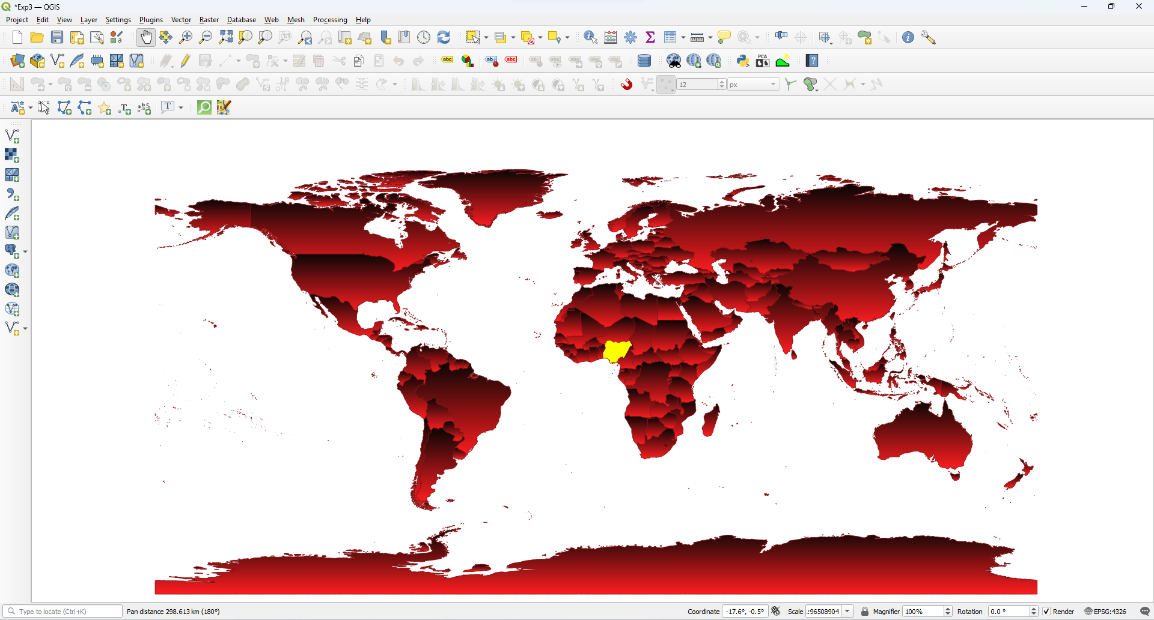

# Step 2: Open the Attribute Table

# Right-click on the layer in the Layers panel.

# Select Open Attribute Table.

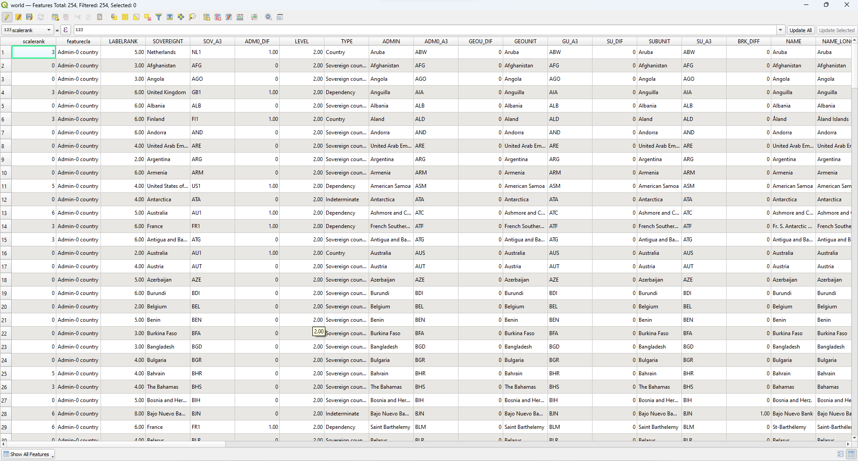

# Step 3: Add a New Field for Calculations

# In the attribute table, click on the Field Calculator icon (it looks like an abacus).

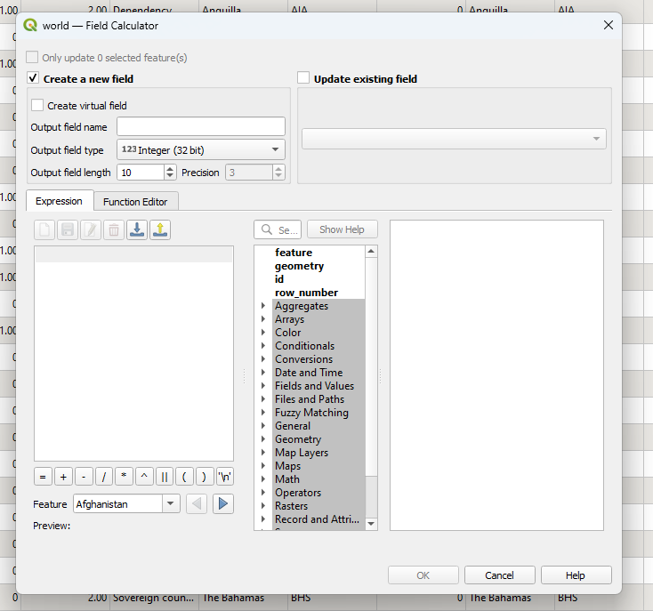

# Step 4: Calculate Area

# In the Field Calculator dialog:

# Check the option Create a new field.

# Enter a name for the new field (e.g., "Area").

# Set the output field type to Decimal number (real).

# In the Expression field, enter the following expression to calculate the area in square meters:

# $area

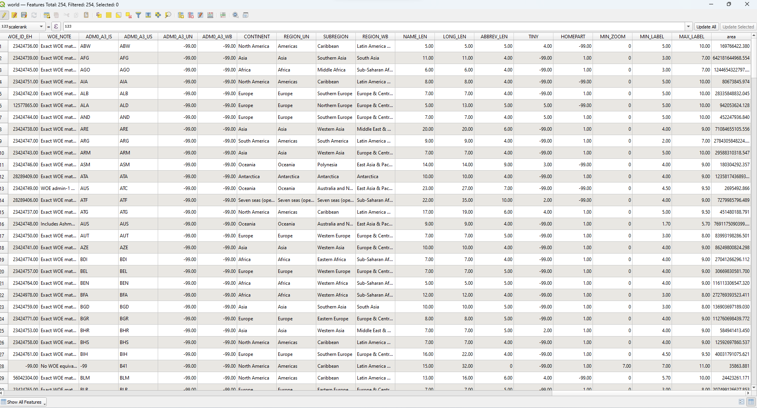

To get the area in hectares:

$area / 10000

Click OK to create the new field and calculate the areas.

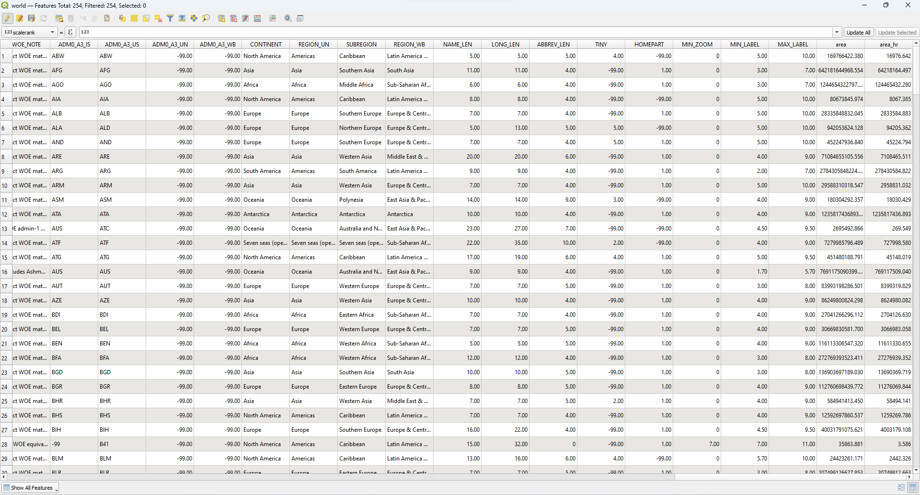

Step : Calculate Perimeter (for polygons):

perimeter($geometry)

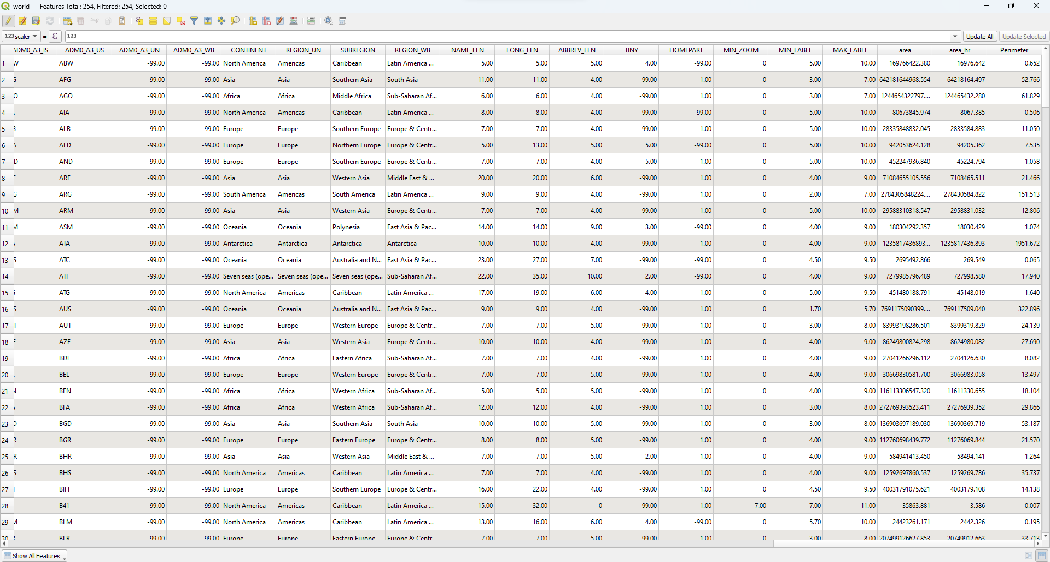

**Task: To work on other geometric properties like centroid using different expressions in the Field Calculator.**

# Platform used by the student: QGIS

# Following points should be written by students

# Different Geometric Properties used in spatial data analysis.

# Students need to write comments wherever needed

### Length

* **Description:** The length refers to the measure of a line geometry. This property is used in network analysis, transportation studies, and hydrological modeling.
* **Common Use:** Calculating road lengths, river lengths, or pipeline distances.

$length

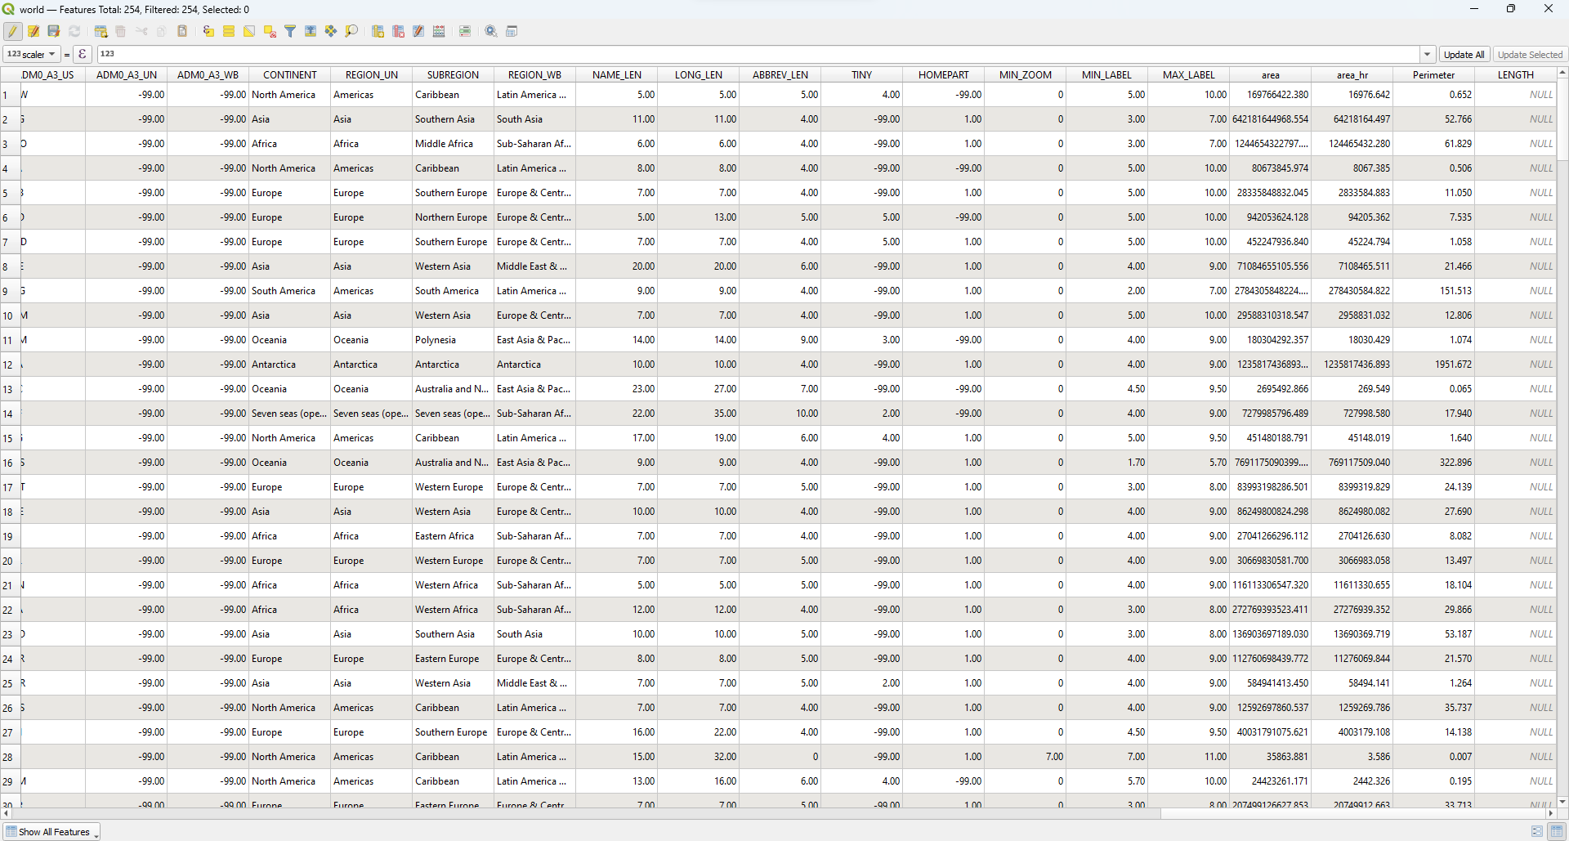

### Centroid

* **Description:** The centroid is the geometric center of a polygon, often considered the center of mass or balance point. It’s used in spatial distribution analysis and for locating the average position of a spatial feature.
* **Common Use:** Finding the center point of administrative regions for labeling or spatial statistics.

**X(Centroid($geometry)**

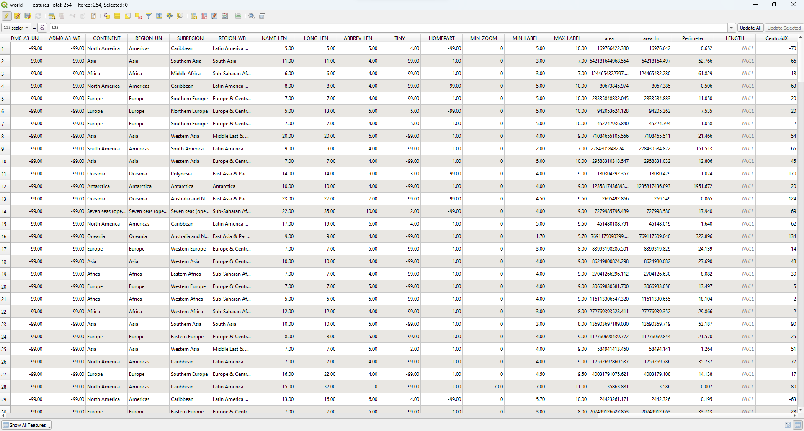

**Y(Centroid($geometry)**

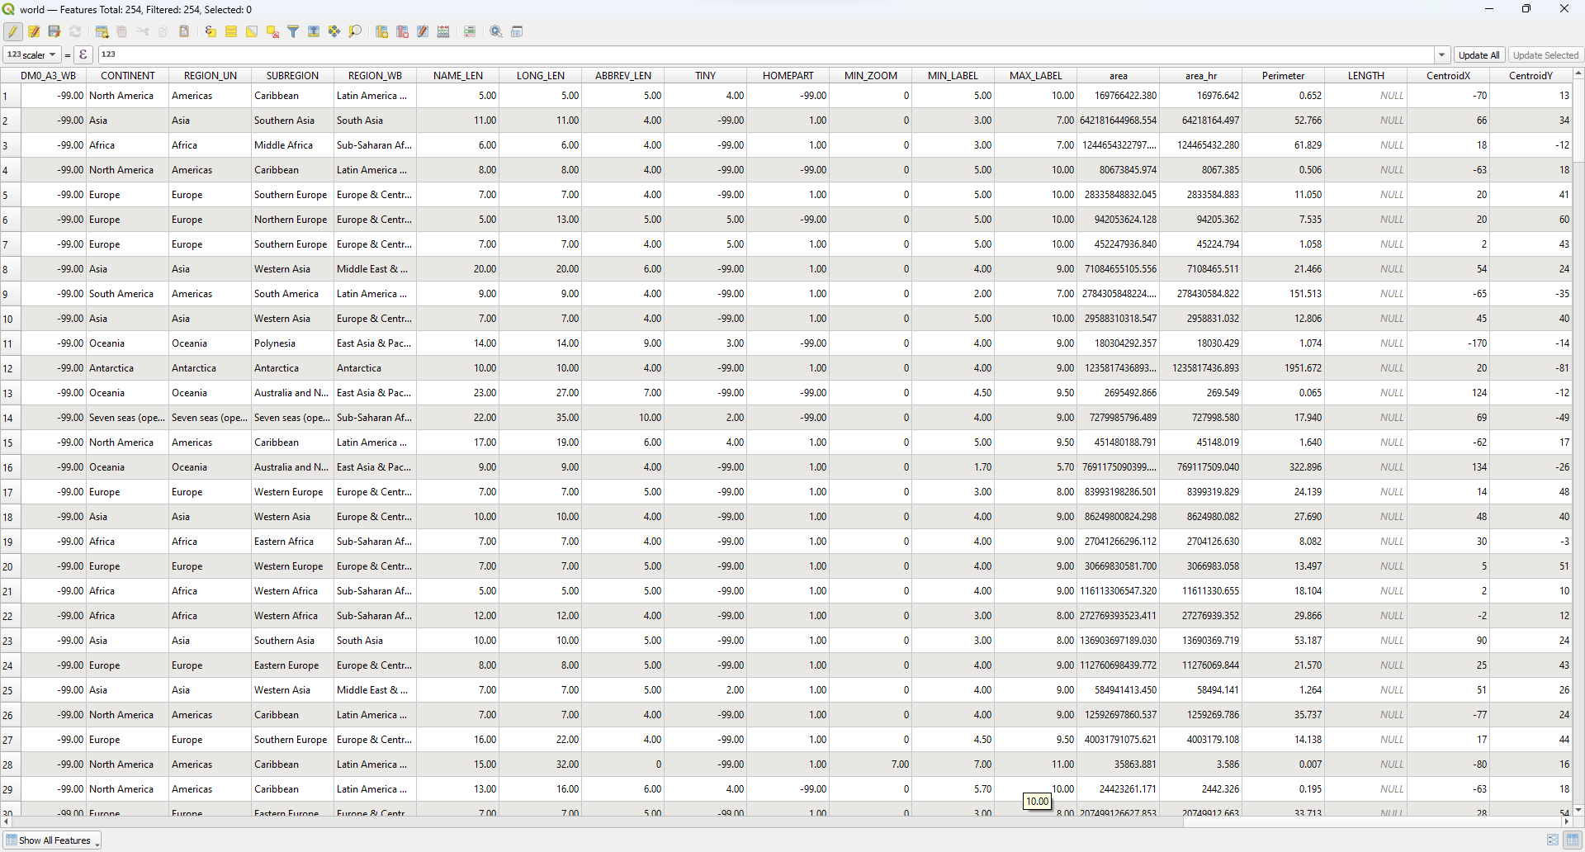

### Centroid Distance

* **Description:** The distance between the centroids of two geometries. It’s used in clustering and proximity analysis.
* **Common Use:** Comparing the spatial dispersion of different regions or features.

### . Open the Field Calculator

* Once the centroid layer is created, you can calculate the distances between the centroids.
* If you want to calculate the distance between each centroid and a specific reference centroid (e.g., the centroid of a particular country), you will need to identify that centroid first.

### 4. Identify Reference Centroid (Optional)

* If you need to calculate distances from a specific centroid:
  + Open the attribute table of the world_centroids layer.
  + Locate the row corresponding to the reference country.
  + Note its coordinates or calculate them using the Field Calculator with the following expressions:
    - **X Coordinate:**  
      x($geometry)
    - **Y Coordinate:**  
      y($geometry)
* Alternatively, you can save the centroid of that specific country as a separate layer.

### 5. Calculate Centroid Distances

* To calculate the distance between centroids:
  + Open the attribute table of the world_centroids layer.
  + Open the Field Calculator.
  + Choose Create a new field.
  + Enter a name for the new field (e.g., centroid_dist).
  + Set the Output field type to Decimal number (real).
* **Expression for Centroid Distance (from a specific reference centroid):**

distance($geometry, make_point(<X_reference>, <Y_reference>))

### Intersecting Area

* **Description:** The area of overlap between two or more geometries. It's used in overlay analysis to understand shared spaces.
* **Common Use:** Studying habitat overlaps or land use conflicts.

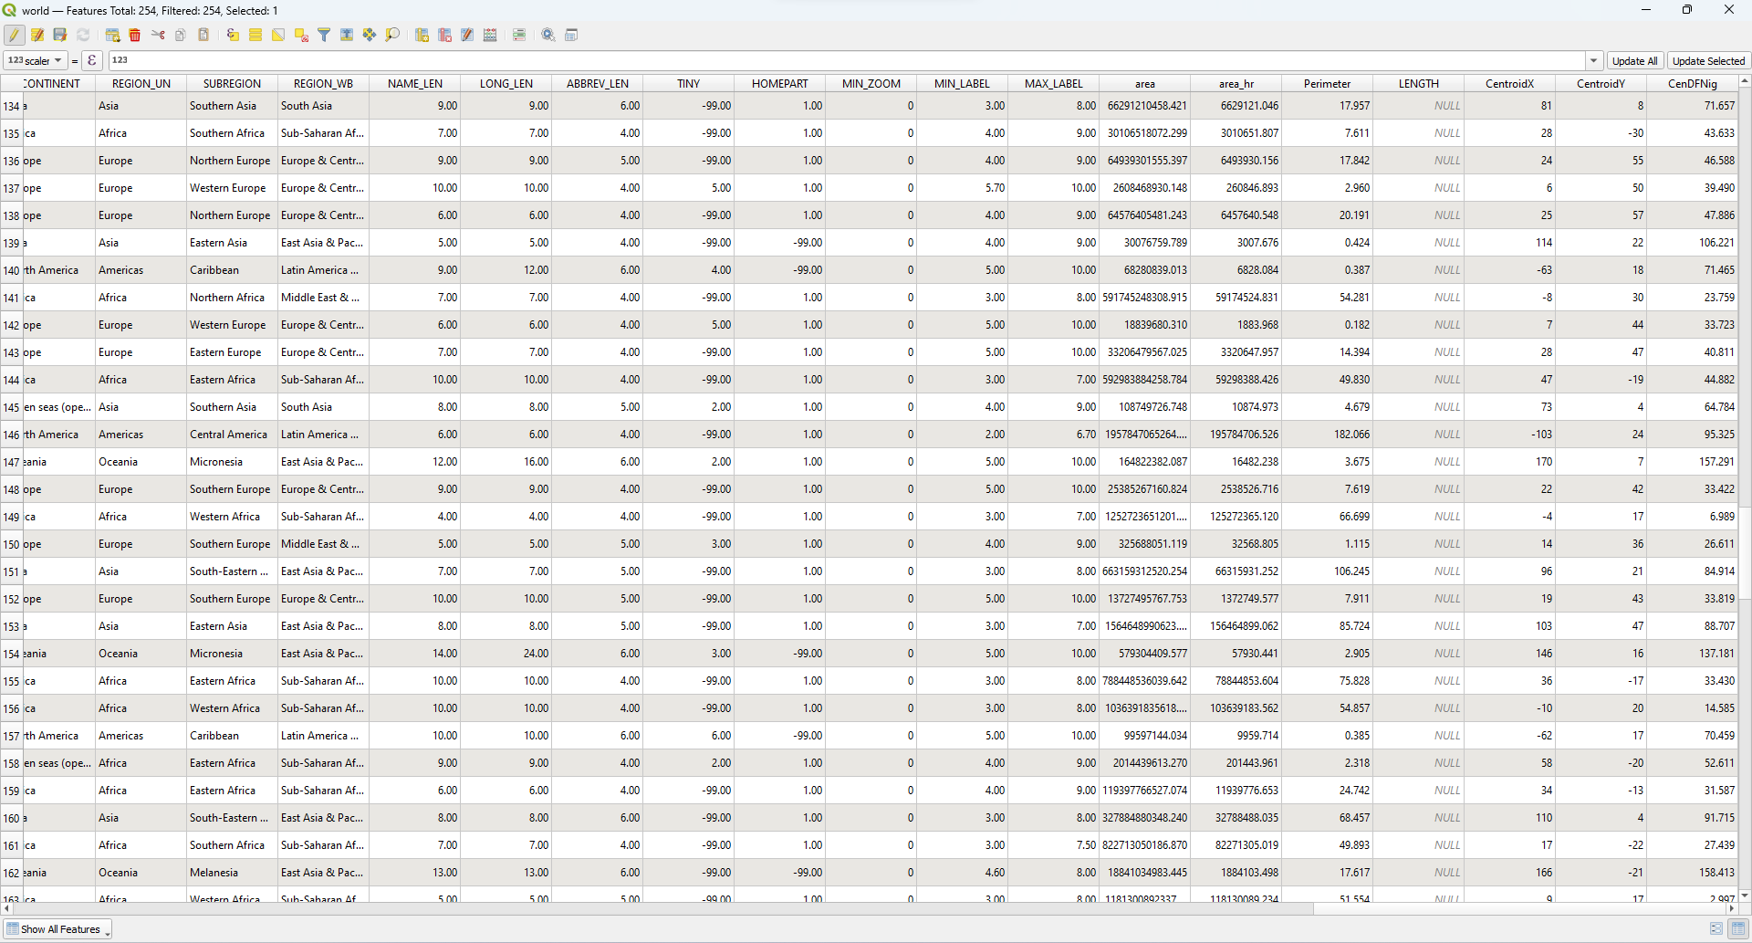

# Conclusion: I have successfully completed this experiment using QGIS. Through this experiment, I learned how to implement spatial data analysis on vector data by calculating different geometric properties such as area, perimeter, centroid, centroid distance, and intersecting area using the Field Calculator. This experiment helped me understand how spatial relationships and geometric measures can be derived and analyzed for real-world applications like urban planning, resource management, and environmental studies.

**Post lab questions:**

**Q.1 What are different geometric properties used in spatial data analysis on vector data with expression?**In vector data analysis, geometric properties help analyze shapes and spatial relationships of features like points, lines, and polygons. Common properties include area (Area(geometry)) and length or perimeter (Length(geometry)), which measure the size and boundaries of features. Centroid (Centroid(geometry)) gives the center point. Geometry type (GeometryType(geometry)) identifies the feature type, and the number of vertices (NumPoints(geometry)) counts points in a shape. Other operations include buffering (Buffer(geometry, distance)) and intersections (Intersection(geom1, geom2)) to analyze spatial relationships.

**Q.2 What are different geometric properties used in spatial data analysis on raster data with expression?**Raster data is made of grid cells, and analysis focuses on cell values and arrangement. Key properties include cell size (cellsize(raster)), extent (extent(raster)), and the number of rows and columns. Raster statistics like mean, min, and max summarize pixel values. Slope and aspect analyze terrain, while zonal statistics extract values within defined zones.

**Q.3 What is spatial data analysis and its advantages?**Spatial data analysis is the study of geographic data to find patterns, relationships, and trends. It helps in better decision-making, resource management, risk analysis, and visualization through maps. It also supports predictive modeling and integrates diverse datasets, making it valuable in fields like urban planning, environment, and disaster management.